

Title: Medicore Hospitals Data Analysis

By:
SURYA

Table of Contents

1. Objective
2. Our Step-by-Step Process
3. Tools & Technology Used
4. Business Problem
5. Dataset Overview
6. Data Preparation
7. Exploratory Data Analysis (with Charts)
8. Statistical Analysis
9. Key Insights
10. Business Recommendations
11. Conclusion

Objective

MediCore Health Network runs six departments across four regions and sixteen cities. This project looks at 10,879 clean patient visit records from 2,993 patients, covering January 2024 to December 2025.
The main objective is to turn the raw patient data into a clean, reliable asset, and then use it to help leadership boost overall revenue. This includes checking department-wise revenue to see which departments are earning well and which are falling behind, tracking whether readmissions are increasing, and understanding how length of stay and patient satisfaction affect the hospital's performance.
Along with revenue and readmissions, the project also aims to clean and organize the raw hospital data properly, since the original file had duplicate entries, missing values, and formatting issues that made it unreliable for decision-making. Once cleaned, the data is checked using simple statistics to make sure the patterns found (like which departments cost more or have more readmissions) are real trends, not random chance.
The project also aims to compare performance across regions (North, South, East, West), not just departments, to see if any region needs extra attention. Finally, the objective is to turn all these findings into a simple, easy-to-read report with charts, so that leadership can use it directly for planning next year's budget, staffing, and patient care improvements — without needing to go through raw data themselves.
In short, the project aims to answer: Which departments make the most and least revenue? Are readmissions going up, and where? Which departments are running efficiently, and which need attention? The answers guide next year's budget, staffing, and department-level decisions.

Step by Step by Process
Every good data project follows a clear process. This is important because it shows the complete flow of the project, from setting the goal to giving final recommendations. The picture below shows the 8 steps we followed for this project.

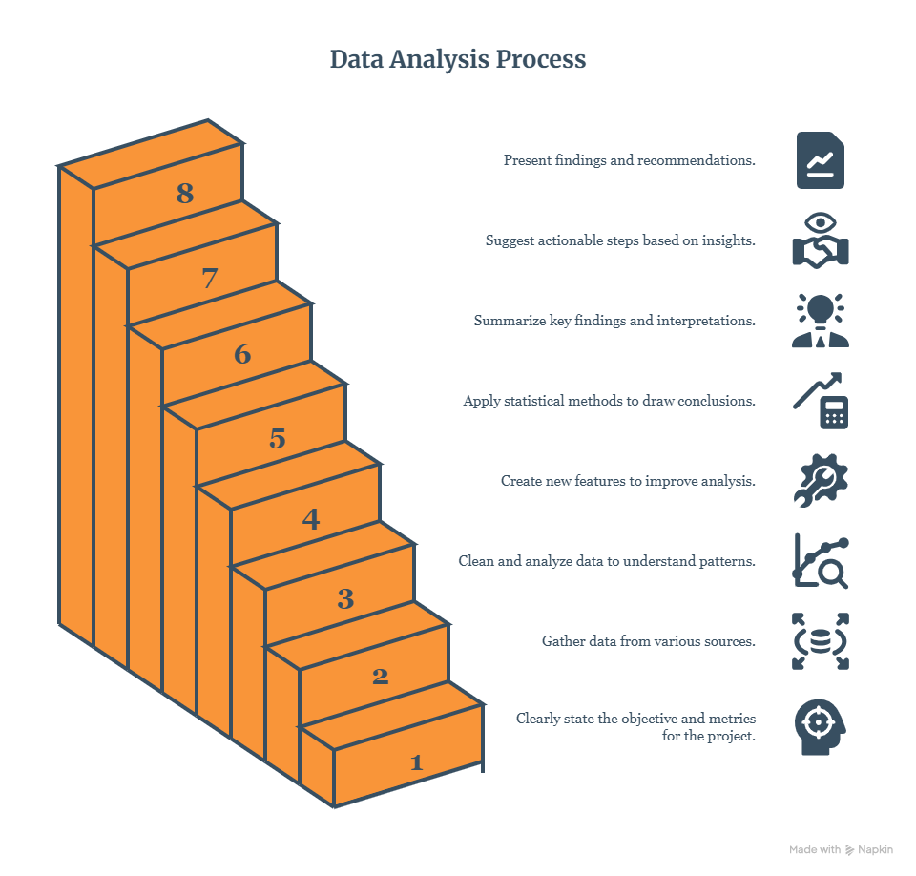

Tools and Technology Used
Tool / Library | Used For
Python | Main programming language used for the whole project
Jupyter Notebook | Environment used to write and run the code step by step
Pandas | Cleaning, organizing, and analysing the data
NumPy | Handling numbers and calculations
Matplotlib & Seaborn | Creating charts and graphs
SciPy (stats module) | Running statistical tests (t-test, chi-square, Kruskal-Wallis, correlation)
scikit-posthocs | Running the Dunn's post-hoc test after Kruskal-Wallis
Microsoft Word | Building this final report
CSV files | Format used for the raw and cleaned data

Business Problem
Company Background
MediCore Health Network runs a group of mid-sized multi-specialty hospitals across India. It offers inpatient and outpatient care in six departments — Cardiology, Orthopaedics, General Medicine, Paediatrics, Oncology, and Emergency. Over the last two years (Jan 2024 – Dec 2025), the network has been moving its records online across four regions (North, South, East, West) and sixteen cities. This has built up more than 12,000 patient visit records from around 3,000 patients.
Context
The Chief Medical Officer and the VP of Hospital Operations asked the Data team to check the patient visit database. They had noticed that bed usage was uneven across departments, readmission complaints were going up, and it was not clear which departments were giving good value for money. Before setting next year's staffing and budget, they wanted real evidence from clean data and proper testing — not just opinions from department heads.
Data Available
We started with one raw file (medicore_raw.csv) that combined data from the Hospital Information System and the billing system. Like most raw exports, it had problems: duplicate rows from a syncing issue, missing values, mixed text formats, mixed date formats, and some incorrect entries from manual typing.

Stakeholders
- Chief Medical Officer (CMO)
- VP of Hospital Operations
- Department Heads (Cardiology, Orthopaedics, General Medicine, Paediatrics, Oncology, Emergency)
- Patient Experience / Quality of Care Team

Dataset Overview
The raw file, medicore_raw.csv, has 13,453 rows and 14 columns, combined from the hospital system and the billing system.
Column | What It Means
patient_id / visit_id | Unique ID for each patient and each visit
admission_date | Date the patient was admitted
department | Cardiology, Orthopedics, General Medicine, Pediatrics, Oncology, Emergency
region / city | 4 regions, 16 cities
patient_age | Age of the patient
gender | Patient gender
length_of_stay | Number of days admitted
billing_amount | Total bill in ₹
insurance_type | Self-Pay, Private, Corporate, Government Scheme
is_emergency | Emergency visit or scheduled visit
readmission | Was this visit a readmission? (Yes/No)
satisfaction_score | Patient satisfaction rating, 1 to 5

Before cleaning, we found some common issues: duplicate visit rows, missing values in a few columns, inconsistent text (like "orthopedics" vs "ORTHOPEDICS"), mixed date formats, and a few wrong entries such as negative age or negative stay length.

Data Preparation
We cleaned the data step by step in medicore_cleaning.ipynb, and kept a log of every row removed, so the process is easy to check.
Cleaning Steps
- Removed duplicate rows.
- Turned blank/whitespace text into proper missing values.
- Fixed Patient_Age: made negative values positive; removed ages above 100.
- Fixed Length_Of_Stay: made negative values positive; removed extreme outlier values.
- Removed extreme outlier values in Billing_Amount.
- Filled missing Length_Of_Stay with the median (3.0 days); filled missing Patient_Age with the average (44.2 years).
- Filled missing Insurance_Type and Satisfaction_Score using random values that kept the same overall pattern as the real data.
- Filled missing Billing_Amount using the typical value for similar visits (same department, stay length, insurance, and emergency status).
- Made all text consistent (for example, "GENERAL MEDICINE" and "general medicine" both became "General_Medicine").
Fixed the date format and made sure every column had the correct data type (numbers
Cleaning Impact
Step | Rows Removed
Duplicate rows | 1,441
Patient_Age above 100 | 85
Length_Of_Stay outliers | 884
Billing_Amount outliers | 164
Total removed | 2,574

After cleaning, the dataset went from 13,453 raw rows to 10,879 clean rows (about 81% kept), with no missing values left in any column.

Exploratory Data Analysis
Using the 10,879 clean visits, here are the main numbers for the whole network:
₹34.84 Cr  Total Revenue | 2,993  Unique Patients | 10,879  Total Visits | ₹32,028  Avg. Billing
3.28 days  Avg. Length of Stay | 26.82%  Emergency Visits | 15.86%  Readmission Rate | 4.26 / 5  Avg. Satisfaction

Revenue by Department
Cardiology brings in the most revenue, and Pediatrics brings in the least. This gap matters for planning next year's budget.

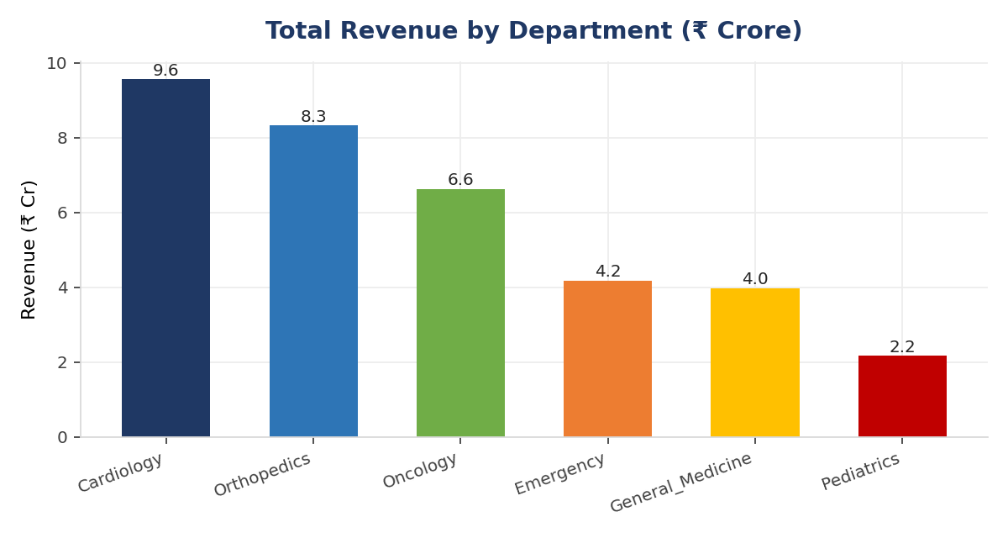

Patient Satisfaction by Department
Pediatrics and Emergency have the happiest patients. Oncology and Cardiology have the lowest satisfaction scores.
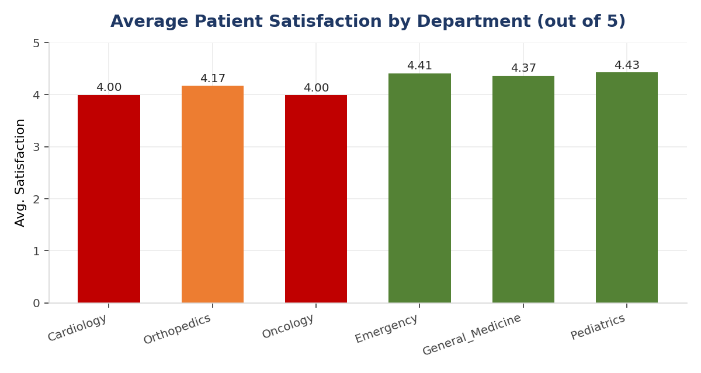

Readmission Rate by Department
Oncology and Cardiology have the highest readmission rates, both above 22%. Pediatrics has the lowest, at about 12%.
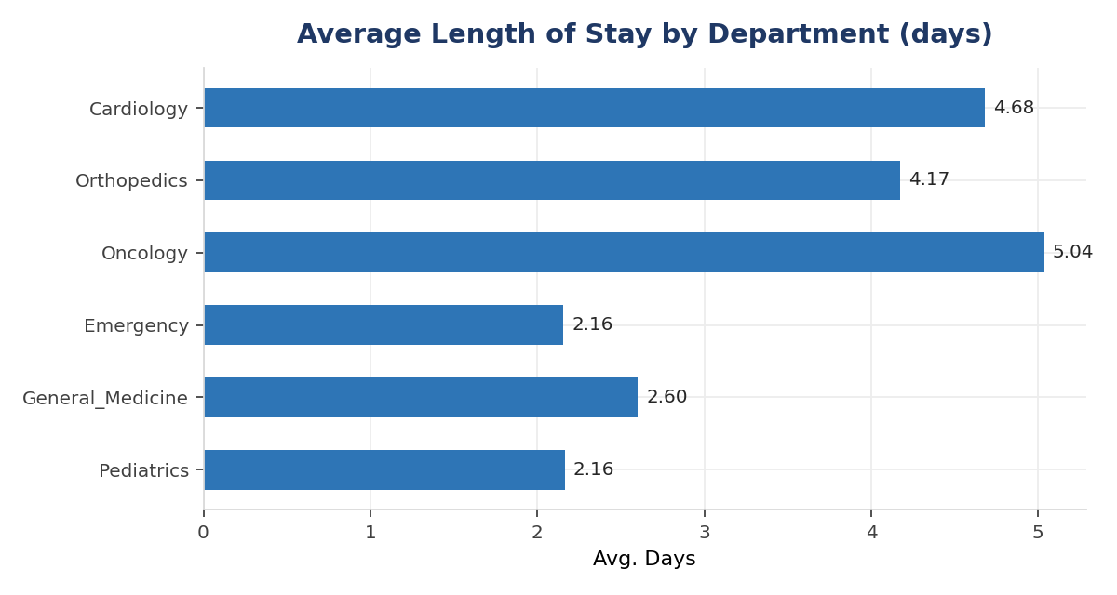

Revenue by Region
Revenue is spread almost evenly across the four regions, with North slightly ahead.

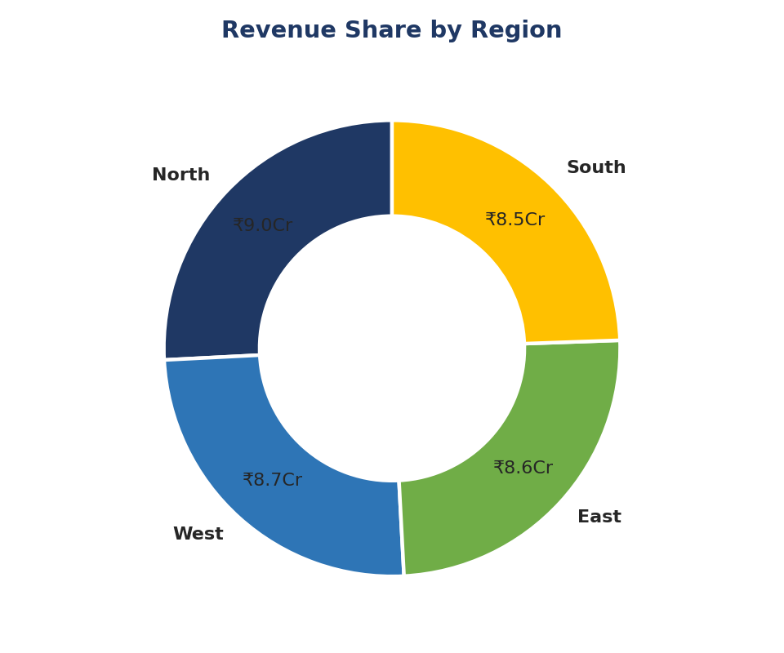

Region | Total Revenue (₹) | Avg. Satisfaction | Visits
North | 8,99,41,708 | 4.263 | 2,769
West | 8,72,01,197 | 4.243 | 2,723
East | 8,61,47,593 | 4.261 | 2,747
South | 8,51,44,782 | 4.262 | 2,640

Statistical Analysis
We ran 5 statistical tests to check if the patterns we saw were real, and not just random chance. Here is a simple summary of all 5:
 | What We Checked | Test Used | Result
1 | Stay length: Emergency vs Scheduled visits | T-test | Real difference found (p < 0.001)
2 | Stay length across the 6 departments | Kruskal-Wallis test | Real difference found (p < 0.001)
3 | Department and readmission link | Chi-square test | Real link found (p < 0.001)
4 | Insurance type and billing amount | Kruskal-Walli’s test | No real difference (p = 0.72)
5 | Stay length vs billing amount, and vs satisfaction | Correlation test | Both links are real (p < 0.001)

Emergency vs Scheduled: Length of Stay
Emergency patients and scheduled patients do not stay for the same number of days on average. The test confirms this is a real difference, not chance. This means beds for emergency and scheduled patients should be planned separately.
8.2 Length of Stay Across Departments
Average stay length is not the same across the 6 departments — the test confirms this. When we compared departments in pairs, almost every pair was different from each other, except Cardiology and Oncology, which behave very similarly to each other, and differently from the rest.
Department and Readmission
Readmissions are not spread evenly across departments. The test shows this link is real. Oncology and Cardiology have the largest share of readmissions.
Insurance Type and Billing Amount
We checked if patients with different insurance types (Self-Pay, Private, Corporate, Government) are billed differently. The test shows no real difference. So, insurance type is not the reason behind billing differences — the department and stay length matter more.

Length of Stay vs Billing and Satisfaction
Longer stays are strongly linked to higher bills — this makes sense, since more days in hospital means a higher bill. Longer stays are also linked to lower satisfaction, though this link is weaker. Both results are statistically real.
Key Insights
1. Cardiology and Oncology need attention
Patients in these two departments stay in the hospital longer, come back more often after being discharged, and are less happy with their care compared to other departments. This isn't random ,it's a consistent pattern.
2. Oncology costs the most per visit, but Cardiology earns more overall
A single Oncology visit is the most expensive one on average. But Cardiology treats a lot more patients, so it brings in more total money for the hospital.
3. Pediatrics and Emergency are doing great
These departments have short stays, lower costs, and the most satisfied patients. Their approach could be a model for other departments to learn from.
4. Emergency and scheduled patients are different
Patients who come in as emergencies stay a different length of time than patients who scheduled their visit in advance. Because of this, beds and staff need to be planned separately for each group.
5. Readmissions depend on the department
Some departments — especially Oncology and Cardiology — have a lot more patients coming back after discharge than others. This is worth the medical team looking into further.
6. Insurance type does not affect billing
Patients aren't charged based on what insurance they have. This is one area that's already working fine and doesn't need fixing.
7. North region is the top performer
Out of all four regions, the North region brings in the most revenue and has the happiest patients.
8. Longer stays mean higher bills and slightly lower satisfaction
The longer a patient stays, the more they get charged, and they tend to be a little less happy with their experience. This makes sense, and now the data proves it.

Business Recommendations
1. Market the low-revenue departments more.
Right now, Pediatrics and General Medicine bring in the least money. Simple things like awareness campaigns and reaching out to the community can bring more patients here safely, since these departments already have low readmission numbers.
2. Run health camps and stay in touch with patients.
Free check-up camps, follow-up calls, or small wellness events can build trust and bring more people into the hospital network over time.
3. Give more budget to departments that need to grow.
Pediatrics, General Medicine, and Emergency should get a bit more marketing budget to help them grow. This is a safer way to increase revenue, because it does not add more load on Oncology or Cardiology, which already have high readmissions.
4. Work on patient experience in Cardiology and Oncology.
These two departments have the lowest satisfaction scores. Small changes like talking to patients better, cutting down wait times, and checking in after treatment can slowly build back their trust.
5. Keep watching the West region.
Its satisfaction score is a little lower than the rest. Nothing urgent, but regular check-ins can stop small issues from becoming big ones.

Conclusion
We started with a messy file of 13,453 patient visits and cleaned it down to 10,879 solid, usable records. Using this clean data, we were able to answer the questions leadership had.
The results all point the same way: Cardiology and Oncology cost the most and have the most readmissions, while Pediatrics and Emergency run smoothly with happy patients. Emergency and scheduled patients need to be planned separately, since they don't behave the same way. Readmissions are tied to specific departments, so leadership now knows exactly where to start looking. Insurance type has no real effect on billing, so that's not something worth chasing further.
A Few Things to Keep in Mind
- Some extreme values were removed while cleaning the data (about 19% of the original rows), so a few real but unusual cases may have been left out.
- Some missing values were filled in using estimates, so those specific numbers aren't the exact original ones.
- This report only covers Jan 2024 to Dec 2025. Anything before or after that period isn't part of this data.

